Grave Shortages of Protective Gear Flare Again as Covid Cases Surge
Five months into the pandemic, the U.S. still hasn’t solved the problem. The dearth of supplies is affecting a broad array of health facilities, renewing pleas for White House intervention.
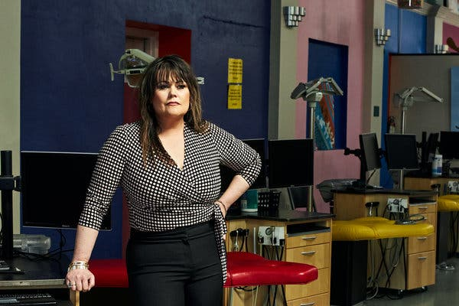
Kay Kennel at Lubbock Kids Dental, a clinic serving low-income families that has a list of 50 children awaiting emergency surgery, in Lubbock, Texas.Credit...Dylan Cole for The New York Times
By Andrew Jacobs
- July 8, 2020

As coronavirus cases surge across the country, hospitals, nursing homes and private medical practices are facing a problem many had hoped would be resolved by now: a dire shortage of respirator masks, isolation gowns and disposable gloves that protect front-line medical workers from infection.
Unlike the crisis that caught a handful of big city hospitals off guard in March and April, the soaring demand for protective gear is now affecting a broad range of medical facilities across the country, a problem public health experts and major medical associations say could have been avoided if the federal government had embraced a more aggressive approach toward procuring and distributing critical supplies in the early days of the pandemic.
Doctors at Memorial City Medical Center in Houston who treat Covid-19 patients have been told to reuse single-use N95 respirator masks for up to 15 days before throwing them out. The country’s largest organization of registered nurses found in a survey of its members in late June that 85 percent had been forced to reuse disposable N95 masks while treating coronavirus patients. In Florida, some hospitals are handing out only loosefitting surgical masks to workers treating newly admitted patients who may be asymptomatic carriers.
The inability to find personal protective equipment, known as P.P.E., is starting to impede other critical areas of medicine too. Neurologists, cardiologists and cancer specialists around the country have been unable to reopen their offices in recent weeks, leaving many patients without care, according to the American Medical Association and other doctor groups.
ADVERTISEMENT
Continue reading the main story
“We have kids living with grapefruit-sized abscesses for over three months who can’t eat or drink and there’s nothing we can do for them because we can’t get P.P.E.,” said Kay Kennel, the chief officer of Lubbock Kids Dental, a clinic serving low-income families in Texas that has a list of 50 children awaiting emergency surgery. “It’s been just horrible, and given the growing number of infections here, I’m afraid things are going to get worse.”
In a coronavirus briefing on Wednesday, Vice President Mike Pence downplayed the shortages, but said the government was preparing to issue new guidance on the preservation and reuse of protective gear. “P.P.E., we hear, remains very strong,” he said.
- Unlock more free articles.
Create an account or log in
Many of the problems of early spring, when hospital workers in New York, New Jersey, Michigan, California and other states first walloped by the virus scrambled to obtain rudimentary protective gear, have only grown. The United States remains dependent on overseas manufacturers and fly-by-night middlemen who have jacked up prices sevenfold amid soaring global demand, according to supply chain specialists and public health experts, who warn that the problem will intensify as the pandemic spreads. The handful of American companies still making protective equipment domestically say they are already at maximum capacity.
“It’s been chaos for us,” said Randy Bury, president of the Good Samaritan Society, which has struggled to keep its 200 nursing homes supplied with hand sanitizer, masks and gowns. “The supply chain in the United States is not healthy, and we’ve learned we cannot depend on the government.”
The crisis has reinvigorated calls for President Trump to invoke the Defense Production Act and order American manufacturers to step in and help. The presumptive Democratic presidential nominee, former Vice President Joseph R. Biden Jr., said this week that he would use that law to boost domestic protection of medical gear if elected.

Editors’ Picks

‘I Am Going to Physically Explode’: Mom Rage in a Pandemic

‘We Both Wound Up at a Corner Waiting for the Light to Change’

A Teacher Held a Famous Racism Exercise in 1968. She’s Still at It.

Continue reading the main story
ADVERTISEMENT
Continue reading the main story
“It’s incredibly frustrating because a lot of attention was paid to the need for ventilators early on in the pandemic, but now we’re realizing that there’s going to be a tremendous ongoing need for simple things like masks, gowns and face shields,” said Dr. Susan R. Bailey, president of the American Medical Association, which last week wrote a letter to Mr. Pence urging the administration to use the Defense Production Act. “We need a national coordinated strategy.”

Latest Updates: Global Coronavirus Outbreak

Updated 5h ago
- In addition to a national record, at least five states set single-day records for infections.
- When a vaccine arrives, who should get it first? U.S. officials have plans, and some tough choices.
- Unemployment claims in the U.S. may be leveling off after a steady fall.
See more updates
More live coverage: Markets
In recent weeks, congressional Democrats along with a growing number of governors and medical associations have been urging the White House to play a more muscular role in the production, procurement and distribution of crucial supplies. They are also urging the administration to tackle the flagrant price gouging that has frozen many long-term care facilities, low-income health clinics and small hospitals out of the market.
Mr. Trump has resisted using federal powers to address the problem, saying in March that individual governors should find their own gear because “We’re not a shipping clerk.” With the National Strategic Stockpile depleted, states have been left to fend for themselves, though the Federal Emergency Management Agency has been distributing modest shipments of gear to nursing homes and long-term care facilities.
At GetUsPPE, a volunteer organization that helps health care facilities and workers find protective gear, demand has been rising sharply in states experiencing a surge of infections. In June, the amount of P.P.E. requested from medical providers in Iowa jumped 440 percent from the previous month, and more than 200 percent in Texas and Louisiana.
“I feel horrible for the health care workers and hospitals that are dealing with this,” said Dr. Ali Raja, a founder of the organization and an emergency room doctor at Massachusetts General Hospital. “They are crying out for help.”
Members of National Nurses United, the country’s largest organization of registered nurses, said they were worried about the ability of reused masks to filter out virus particles after so much wear and tear. Many are also concerned about the health implications of a chemical decontamination process recently approved for emergency use by the Food and Drug Administration that involves spraying soiled masks with hydrogen peroxide. The F.D.A. has also granted emergency authorization for decontamination procedures that use ultraviolet irradiation and moist heat, though regulators acknowledge that reusing disposable masks is less than ideal.
ADVERTISEMENT
Continue reading the main story
“Nurses and health care workers are being forced to reuse masks with an unproven system,” said Deborah Burger, the organization’s co-president. “It’s almost five months into a pandemic in the richest country in the world and we’re putting people’s lives at risk because we don’t have enough P.P.E.”
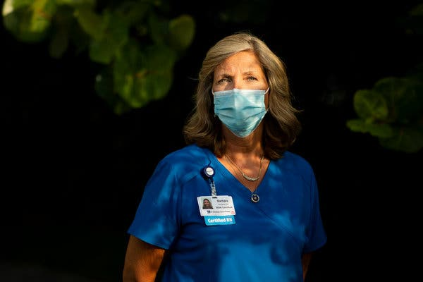
Image
Barbara Murray, a post-operative surgical nurse for St. Petersburg General Hospital, does not work on the COVID-19 unit, so she does not receive an N95 mask.Credit...Tailyr Irvine for The New York Times
The risks are not abstract. More than 900 health care workers have died of Covid-19, according to a tally by the organization, and Ms. Burger said many of the deaths have been linked to inadequate protective gear.
“There are tools at President Trump’s disposal and he has failed us,” she said. “These deaths are entirely preventable.”
FEMA has been distributing 14-day supplies of gear to nursing homes, but many providers have quickly burned through the shipments. There have also been widespread complaints about defective equipment, including child-size gloves, gowns without armholes and loosefitting cloth masks that are ineffective for filtering out virus particles, according to LeadingAge, a national association of nonprofit care providers. The dearth of protective equipment at facilities serving older adults has prompted mounting alarm among public health experts. More than 40 percent of all coronavirus deaths have been linked to nursing homes and long-term care centers, according to a tally by The New York Times.
FEMA said in a statement that it had made changes to most recent shipments in response to feedback from recipients.
The national free-for-all to obtain scarce protective gear has favored large hospital chains with procurement professionals and established supply chains, but even deep-pocketed institutions have been rationing masks and gowns. At St. Petersburg General Hospital in Florida — part of HCA Healthcare, a for-profit chain that includes more than 2,000 hospitals, clinics and surgery centers — medical staff members said they were given a single surgical mask each day to make their rounds; only those assigned to the Covid ward were allowed access to N95s, which are kept under lock and key.
“If you sneeze in your mask, you still have to wear it your entire shift,” said Barbara Murray, a nurse at St. Petersburg General.
ADVERTISEMENT
Continue reading the main story
Ms. Murray said medical staff members worried that surgical masks offered little protection when treating asymptomatic carriers of the virus. She said she was increasingly seized with anxiety as the hospital filled up with coronavirus patients, some of them sent from local nursing homes, because staff members lacked even basic protective gear and were unable to care for them.
Hospital administrators, she said, won’t even allow employees to wear N95 masks they have purchased with their own money. “We’re nurses — we want to take care of our patients and we want them to be safe,” Ms. Murray said. “But at the end of the day, we want to go home to our families and know that they are safe too.”
A spokeswoman for St. Petersburg General declined to comment on the hospital’s mask policies but said adequate supplies were available to employees who needed them.
Across the country, private medical offices, especially those without access to group purchasing networks, are struggling to get protective gear on the open market. Even when they can find them on Amazon and other websites, doctors say they are paying up to $7 for N95 masks that sold for less than a dollar before the pandemic.
“Community physicians have it worse because we are at the bottom of the totem pole,” said Dr. Inderpal S. Chhabra, an internal medicine specialist in New Hyde Park, N.Y., who recently reopened his office but could see only four or five patients a day because of limited supplies. “Everyone is running around like crazy trying to get N95s, but no one can get them. I afraid for my staff.”
At Arizona Community Physicians, a private health clinic in Tucson, medical technicians are not given N95 masks but they are still required to see Covid-19 patients, who arrive for nonemergency procedures like mammograms, ultrasounds and chest X-rays, according to two employees who asked to remain anonymous for fear they could lose their jobs. The employees say they have been unable to buy medical grade N95 masks online; some vendors have run out of supplies while others say they won’t sell to individuals. “Every day I go into work and I am scared to death — not just for myself, but for my family,” one worker said.
Arizona Community Physicians did not respond to emails and phone messages seeking comment. A spokesman for the Arizona Department of Health Services said state regulations for protective gear did not apply to private clinics.
ADVERTISEMENT
Continue reading the main story
That’s not the case in Texas, which requires health facilities to have adequate equipment before reopening. State officials said they had distributed 500,000 respirator masks to dental offices, but Ms. Kennel, the chief officer at Lubbock Kids Dental, said her clinic was not among the recipients.
Her employees spend much of their day on the phone trying to calm the parents of children in severe pain. Others show up at the door with their children and beg for help. With dental clinics across the state facing the same problem, the staff can only prescribe antibiotics and tell caregivers to sit tight. Her greatest fear is that an untreated abscess will enter the bloodstream and turn fatal, a preventable death that has claimed dozens of lives in recent years.
“We’re not talking about silver crowns, teeth cleaning or veneers,” Ms. Kennel said, her voice choking with emotion. “These are children with severe infections, and there is nothing we can do for them. It’s just heartbreaking.”
Andrew Jacobs is a health and science reporter, based in New York. He previously reported from Beijing and Brazil and had stints as a metro reporter, Styles writer and national correspondent, covering the American South. @AndrewJacobsNYT
A version of this article appears in print on July 9, 2020, Section A, Page 7 of the New York edition with the headline: Shortages of Protective Gear Still Plaguing Care Facilities. Order Reprints | Today’s Paper | Subscribe

