The SHIN-NY
The New York State healthcare system is one of the largest, most diverse and fragmented healthcare systems in the country. An individual New Yorker may receive healthcare services from multiple healthcare organizations, and in some cases, across a wide geographic region. The Statewide Health Information Network of New York (SHIN-NY) provides a way for healthcare professionals to easily and securely share electronic health information across the entire state, paving the way to significantly improve patient safety and care while reducing wasteful cost in the system.
Today, the SHIN-NY is comprised of nine Regional Health Information Organizations (RHIOs). These organizations were funded and built in collaboration with local healthcare stakeholders to ensure that the regions’ and communities’ needs were best met. Each RHIO operates its own network that aggregates health records from participating providers in their regions. Together, the nine RHIOs connect data from 84% of hospitals in New York State and from more than 50 thousand providers and 34 public health departments. Each RHIO has been certified by the New York State Department of Health to maintain a secure technical infrastructure and follow policies developed by New York State that allow the flow of information while simultaneously safeguarding all patients’ information and right to privacy.
During the past year, more than 10,000 new healthcare providers used the network, and nearly 7 million New Yorkers have provided consent to share their records through the SHIN-NY. Currently, providers can search for patient records within a RHIO; but during the course of 2015, all RHIOs will be interconnected and certified by the New York State Department of Health to enable Statewide Patient Record Lookup (sPRL).
How Will Providers Be Able To Access All Of A Patient’s Clinical Records?
During the past year, the State has invested in the development of technical infrastructure to interconnect the RHIOs. Beginning in July, RHIOs will start to connect to this infrastructure. Once connected, the RHIOs will be able to offer providers Statewide Patient Record Look-Up (sPRL). SPRL lets a participating provider look up records in the system for any patient they are treating in the network who has provided consent to share. While this function has already been available within individual RHIOs’ networks, sPRL will now allow the provider to search for the patient’s records across RHIOs wherever the records reside. So, a family practitioner in Brooklyn can look up her patient’s health records from the patient’s doctors in Binghamton where she received care while attending college, for example. In short, providers will now have a means of easily and securely sharing records between each other.
How does Statewide Patient Record Look-Up Work?
SPRL acts like a secure search engine. A provider can search for a patient’s records within his or her own region and can query the SHIN-NY to obtain clinical data from

other RHIOs. The provider only needs to enter basic demographic information for the specific patient. The SHIN-NY will effectively query all the RHIOs to determine where records reside. Here’s how it works. When a patient record is entered into a RHIO’s network, the patient becomes part of the RHIO’s patient index. All of the RHIO patient indexes are combined into a Master Patient Index for the SHIN-NY. When a provider looks up a patient’s records, the RHIO’s patient index is matched against the Master Patient Index to see what other records reside in other RHIOs. When matches between indexes occur, the records show up in the search results.
When Will Statewide Patient Record Look-Up Be Available?
Beginning July ^{1st}, RHIOs will start to connect to the SHIN-NY technology and sPRL will be available. To ensure a smooth transition, the RHIOs will be connecting to the SHIN-NY in groups of three. This will continue through the end of September. By early October, all RHIOs will be connected to the SHIN-NY, and their records will be available to search by providers connected to other RHIOs.

As a RHIO comes onboard, the patient records from that RHIO become available to search through Statewide Patient Record Look-Up. However, if the patient’s records reside in a RHIO that has not yet connected, the sPRL search will not show those records yet. More and more data will become available on a rolling basis. Once all RHIOs are connected in early October, patients’ records from participating providers can be accessed across the state.

The schedule for onboarding RHIOS is currently planned as follows:
- Group 1: available week of 8/4
  - HealthLinkNY
  - HealtheConnections
  - HIXNY

- Group 2: available week of 8/25
  - Bronx
  - Healthix
  - Interboro

- Group 3: available week of 9/15
  - Rochester
  - HEALTHeLink
  - e-Health Network of Long Island

Further information on the SHIN-NY and sPRL can be found at www.nyehealth.org. For questions, please contact info@nyehealth.org.

Please see map below for information as to which RHIO area your practice is located in.

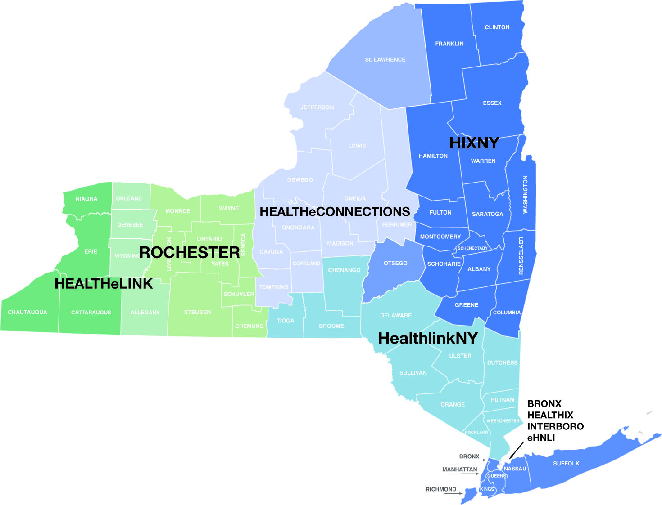

Pending completion of DOH certification process

