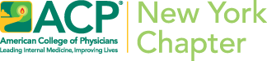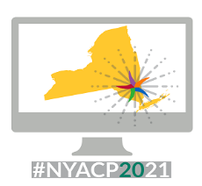
NYACP 2021 Annual SCIENTIFIC MEETING
Sponsorship Opportunities
Thursday, October 7, 2021 / Friday, October 8, 2021

Why Partner with the New York Chapter American College of Physicians?

NYACP is New York’s largest medical specialty organization representing over 12,000 physicians specializing in general and subspecialty Internal Medicine. The mission of the NYACP is to enhance the quality and effectiveness of health care by fostering excellence and professionalism in the practice of medicine.

Internists specialize in adult medicine in both general and subspecialty fields and focus on the prevention, detection and treatment of illnesses in adults. Attendees at our programs range from private practice, multi-specialty practice, chief medical officers, medical directors, chief medical information officers, program directors, clerkship directors, hospitalists and academicians.

Extend Your Reach!

Participation as an exhibitor/sponsor at NYACP’s Live Virtual Annual Scientific Meeting on October 7 and 8, 2021 allows you to extend your reach to not only meeting attendees, but the entire NYACP membership. We invite you to collaborate and meet general internists and subspecialists virtually, as well as market your brand and/or discuss your services. This opportunity puts you in close proximity to our educational events where physicians can be informed of your services and can follow up with you directly!

Please note that full payment must be received with your signed application. The contributions to NYACP are directed to our C-3 Not-For-Profit Corporation (TIN: 52-1289396).

This year, we are offering several sponsorship opportunities. The comprehensive list of packages are:

NYACP Annual Meeting Sponsorship Packages
 | Sponsorship Levels
Sponsorship Opportunities: | Gold $3,000 | Silver $2,000 | Bronze $1,500
Company name/logo on NYACP’s Quarterly Postcard mailing to all 12,000 Chapter members | X
Company name/logo included in social media posts (twitter and FB) | X
Company name/logo in IM Connected (bi-weekly newsletter) | x | x
Company name/logo included in Faculty email promo to all members | x | x
Company name/logo included in all Stand-alone NYACP Annual Meeting promo to members | x | X
Company name/logo listed on NYACP’s Annual Meeting website page | x | x | x
Company name acknowledgment at beginning of NYACP’s 10/7/21 Business Meeting | x | x | x
Company name/logo included in Plenary Sponsorship acknowledgement | X | X | X
Company name/logo included on post conference email reminder about recorded sessions | X | X | X

