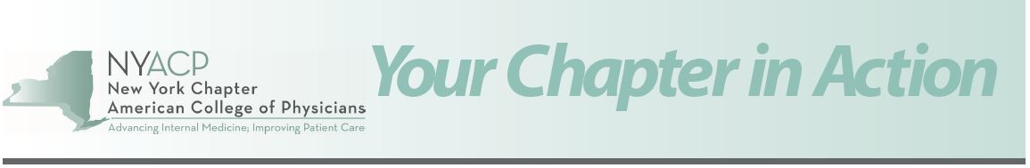
July 25, 2019
NYACP Newsletter: Your Chapter in Action (YCIA)
NYACP Annual Scientific Meeting ... Upcoming Symposium ... Online Auto Insurance Reduction Course ... NYS PCMH and VBP
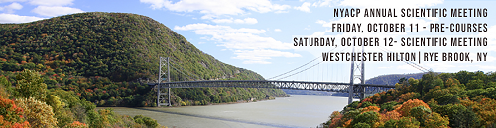
2019 NYACP Annual Scientific Meeting
The New York Chapter American College of Physicians (NYACP) invites you to join your colleagues in Internal Medicine at the 2019 NYACP Annual Scientific Meeting to be held on Friday, October 11 - Saturday, October 12, 2019 at the Westchester Hilton Hotel in Rye Brook, New York.

MOC Pre-Course Brochure - October 11, 2019

Scientific Meeting Brochure- October 12, 2019

Practice Management
Opportunity to Provide Feedback on NYS PCMH and VBP is Right Around the Corner!
The NYS PCMH model is an integrated care delivery and payment model that ties together a service delivery model and reimbursement to promote improved health and health care outcomes that are financially sustainable. The NYS PCMH model was designed to help primary care practices evolve to assure readiness to participate in the Value Based Payment (VBP) models being developed and implemented by both public and private payers.
NYACP, in collaboration with the NYSDOH and Health Research, Inc. (HRI), will be conducting two brief surveys in the next few weeks for (1) physicians that have achieved recognition through the NYS PCMH program; and (2) those that have chosen to not participate in NYS PCMH. The purpose of the surveys will be to assess the effectiveness of the program and identify successes, barriers and concerns on sustainability and capability for value based payment.
Please keep an eye out for the survey and provide your feedback!
”The project described was supported by Funding Opportunity Number CMS 1G1CMS331402 from the U.S. Department of Health & Human Services, Centers for Medicare & Medicaid Services“

Hot Topic: Price Transparency
Price transparency is a hot topic in healthcare. Patients are asking more questions related to the cost of their care. Physicians are incorporating the topic into patient visits as part of whole-person care. NYACP and ACP have supporting resources for addressing this topic. The following are resources for the most common topics encountered in practice:
Getting the Conversation Started
- ACP Conversation Guide – Ideas and phrases to help guide the topic in a patient encounter.
- ACP Steps to Estimate Cost of Care – A template for planning a full course of treatment to help patients plan for costs.
- ACP Medical Treatment and Cost Planning Tool – Describes how to determine the cost of care.
Finding/Getting Better Insurance Coverage
- Medicare Plan Finder – Compare Medicare and Medicare Advantage Plans along with expenses.
- NY State Healthcare Marketplace – Compare commercial plans and expenses.
Estimating and Planning Costs
- What’s Covered – An App for Medicare patients that provides information about coverage by service.
- FAIR Health – A great place to get an idea of local pricing for services. This is useful for uninsured patients and for dental estimates.
- GoodRx – Compare medication costs at local pharmacies and find alternatives. Use it for your pet’s prescriptions, too!
- NYACP Donut Hole Handout – Help Medicare patients learn about and plan for their medication costs.

Finding Assistance
- NeedyMeds – Search $4 generic lists, get a listing of patient assistance programs for medications, transportation and supplies.
- Community Health Advocates – Connect the patient with an organization that helps navigate insurance plans, surprise bills and find assistance programs.

Education
1st Annual International Geriatrics Symposium for the Primary Care Provider
Sponsored by Albany Medical College's Department of Medicine and the Office of Continuing Medical Education and McGill University Division of Geriatric Medicine and in collaboration with the New York Chapter American College of Physicians
September 18-20, 2019 - 8.5 AMA PRA Category I Credits™
The Conference Center
2608 Main Street • Lake Placid, NY 12946
Brochure / Online Registration

Member Benefit
6-Hour Online Auto Insurance Reduction Course.
The NYACP continues to offer a 6-hour Insurance and Point Reduction Course that is approved by the NYS Department of Motor Vehicles and available to NYACP members, their families, office staff and friends. This convenient online member benefit allows registered "students" the ability to start and finish the course within 30 days for only $42.00. The benefit includes a 10% reduction on your automobile insurance (liability, no-fault and collision) and up to 4 points off of your driving record (if applicable). More information can be found by clicking here.

