

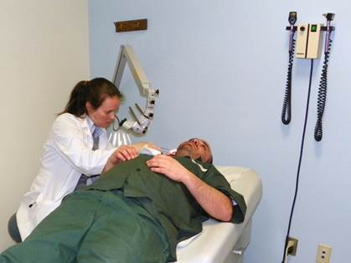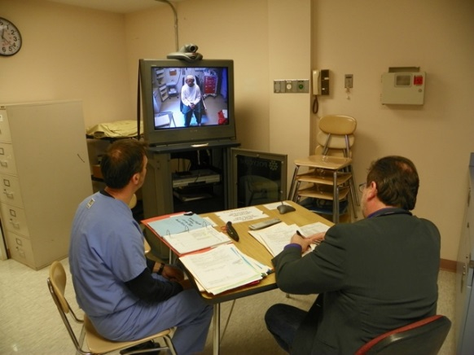

**Clinical Physician 2 – Well equipped and staffed facilities and reasonable patient loads**

Are you looking for a change? Tired of working long shifts with an overwhelming patient load? Come work at a correctional facility where you can make a difference, working with a smaller number of patients for reasonable hours.

The NYS Department of Corrections and Community Supervision’s Department of Health Services operates as a Core Service to promote, restore and maintain the health of incarcerated individuals within safe facilities. There are 54 facilities located throughout the State of New York, serving approximately 50,000 inmates. Medical staff are made up of multi-interdisciplinary teams, which include Physicians, Physician Assistants, Nurse Practitioners, Nurses, Dentists, Pharmacists and other Ancillary positions.

We have great career opportunities for Clinical Physicians. You must possess a license to practice medicine in New York State; have a M.D., D.O. or M.B.B.S. degree; have completed 1 full year of post-graduate training and have 2 years of subsequent medical experience.

Starting salary is $143,381 - $171,631 *(Additional $20,000 geographical differential for Clinton and Franklin County, and $10,000 for Greene and Seneca county).

Benefits include comprehensive health insurance, including dental, vision and prescriptions. NYS retirement system, deferred compensation plan, flexible spending plan, 13 vacation days, 5 personal days, 13 sick days and 12 paid holidays annually.

We have openings in the following counties offering a choice of urban, suburban or rural living:

Chemung Southport Correctional Facility (Finger Lakes)

Clinton* Clinton Correctional Facility (sporting and recreational outlets)

Essex Adirondack and Moriah Correctional Facility (Whiteface, skiing)

Dutchess Green Haven Correctional Facility (Hudson River Valley Beauty)

Franklin* Upstate Correctional Facility (North Country, 1 hour to Montreal)

Greene* Coxsackie and Greene Correctional Facility (Rural charm yet only 2 hours to New York City)

New York Edgecombe Correctional Facility (Empire State Building, Central Park, Times Square, and Chrysler Building)

Oneida Marcy and Mid-State Correctional Facility (Cooperstown, breweries)

Seneca* Five Points and Willard Correctional Facility (heart of wine country)

St. Lawrence Riverview Correctional Facility (5 miles from NYC)

Ulster Ulster Correctional Facility (Catskill Mountains, Casinos)

Washington Washington Correctional Facility (Between Vermont and the Green Mountains)

Westchester Bedford Hills Correctional Facility (Less than 1 Hour to NYC)

Contact: [www.doccs.ny.gov](http://www.doccs.ny.gov) or DOCCS Personnel Office at (518) 457-8132 for more information and to apply.