**MEDICARE DONUT HOLE FAQ’S**

**WILL I REACH THE DONUT HOLE (COVERAGE GAP)?**

If the total drug cost for your medications reaches $3,820 in 2019, you will reach the coverage gap.  
***Total Drug Cost = Plan paid + You paid + Other Programs Paid***

1**. Examples of a Medicare Part D EOB statement.**

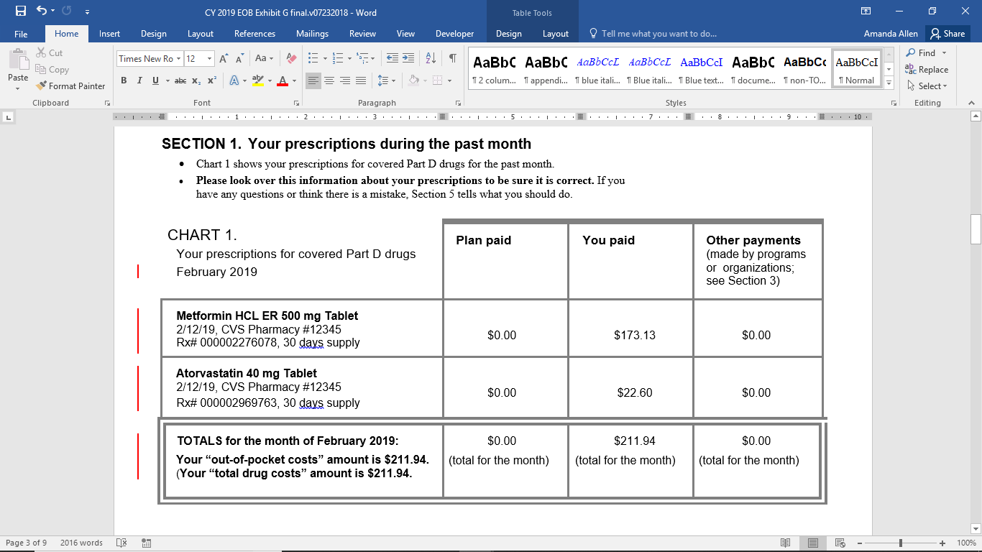

**HOW DO I KNOW IF I AM CLOSE TO THE LIMIT?**

Your monthly Medicare Part D statement will show the total drug cost amount per month and per year. Keep track of your monthly total drug costs to plan ahead. If this amount is the same every month, you can use this total to estimate when you will reach the limit. Always check the year-to-date amount for total drug costs. This will tell you how much has been spent towards meeting the limit.

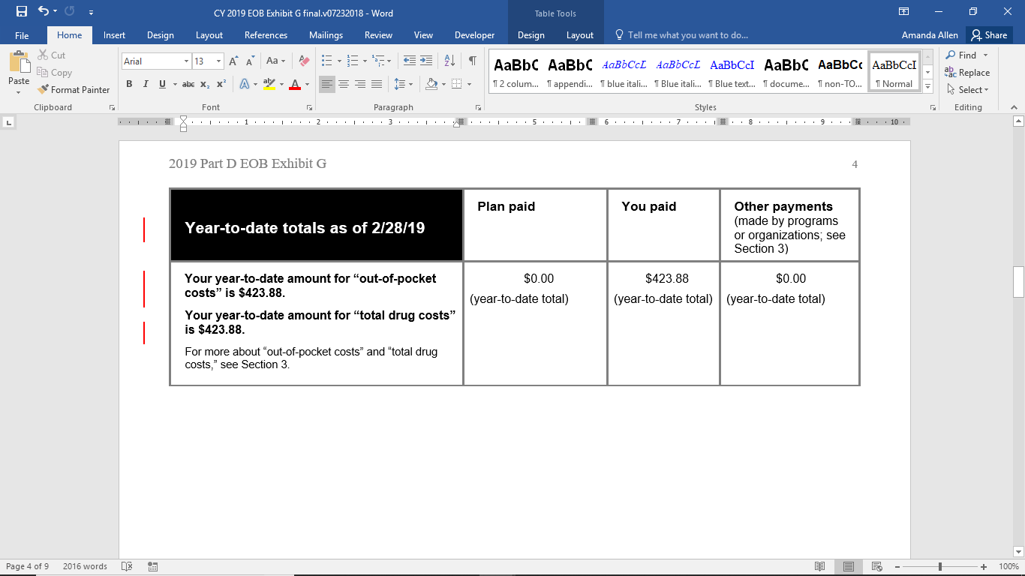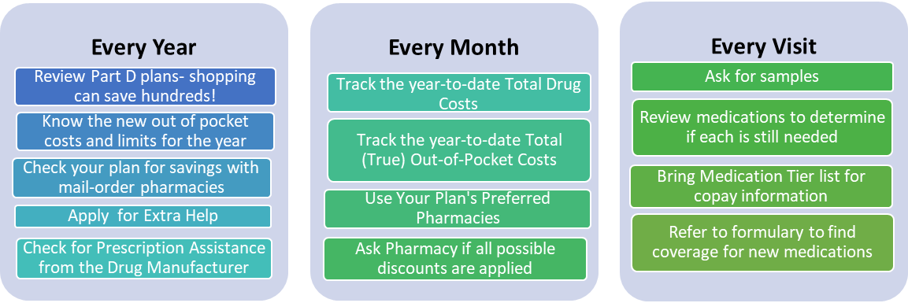

Tools to Help You

* **Compare plans at Medicare Plan Finder**: [www.medicare.gov/find-a-plan/questions/home.aspx](http://www.medicare.gov/find-a-plan/questions/home.aspx)
* **Compare Pharmacy Prices at**: www.GoodRx.com
* **Check for assistance from manufacturers at**: [www.medicare.gov/pharmaceutical-assistance-program/](http://www.medicare.gov/pharmaceutical-assistance-program/)
* **Apply for Extra Help:** 1-800-772-1213 **and NYS EPIC:** 1-800-332-3742

**WHAT CAN I DO TO AVOID OR DELAY THE MEDICARE PART D COVERAGE GAP?**

Plan ahead! Find the right plan, refer to the plan details, keep the covered drug list (Formulary) and research savings.

**HOW DO I GET OUT OF THE MEDICARE PART D COVERAGE GAP?**

Once your total drug cost amounts reach $3,820 in the calendar year, you will reach the coverage gap. In this gap, you will begin paying a higher percentage of the medication cost. The coverage gap ends when your true out-of-pocket spending amount reaches $5,100 for 2019 OR when the calendar reaches January 1, 2020.   
**True Out-of-Pocket Costs = Initial Deductible + Co-payments + Other Organizations Paid**

**TIPS**

* Set some savings aside at the beginning of the year to plan for the increased out-of-pocket costs in the gap.
* If it’s near the end of the year, determine if you have enough medication to wait until after January 1st to get refills.
* Make sure the drug is covered, you get it at a preferred pharmacy and use the benefit card to count towards the total.
* If you won’t reach the gap limit, use tools like GoodRx and ask the pharmacy for cash discounts.